Market Basket Analysis

1. Introduction to Market Basket Analysis

What's market basket analysis?

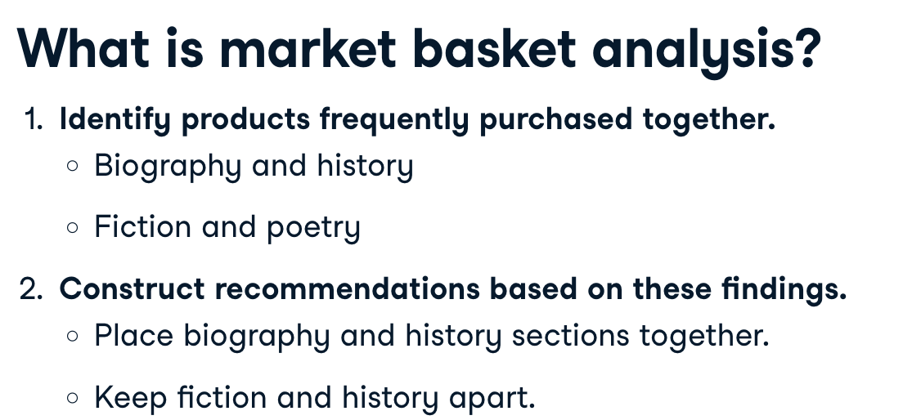

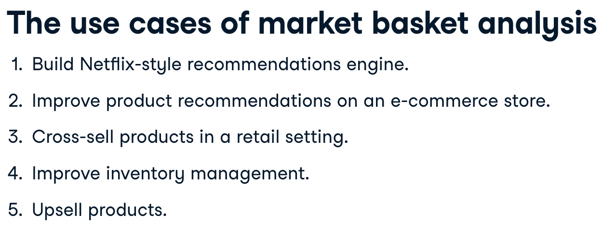

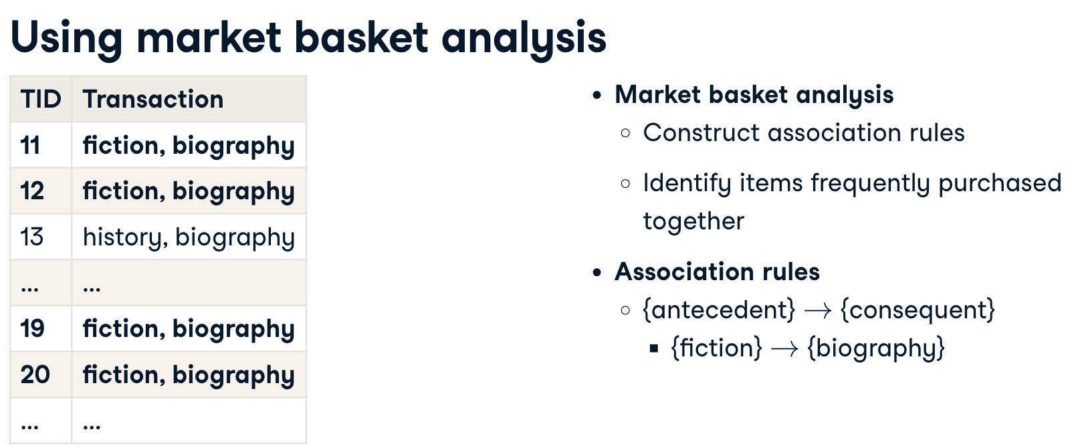

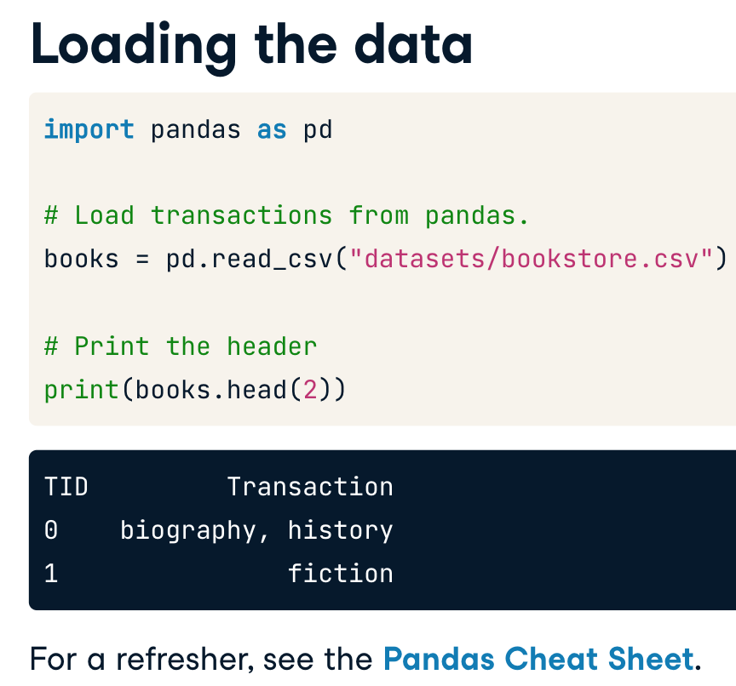

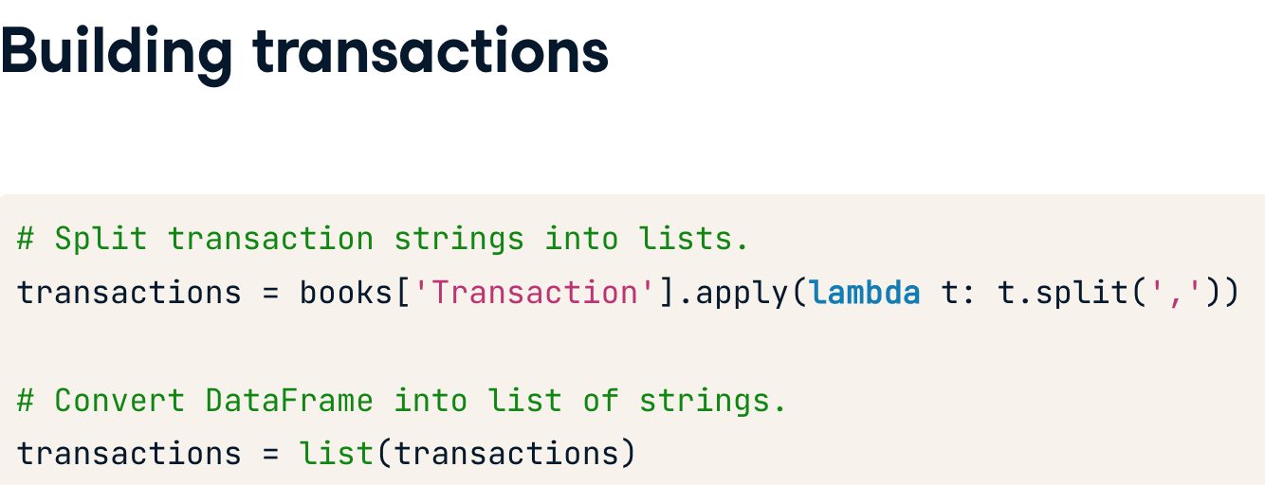

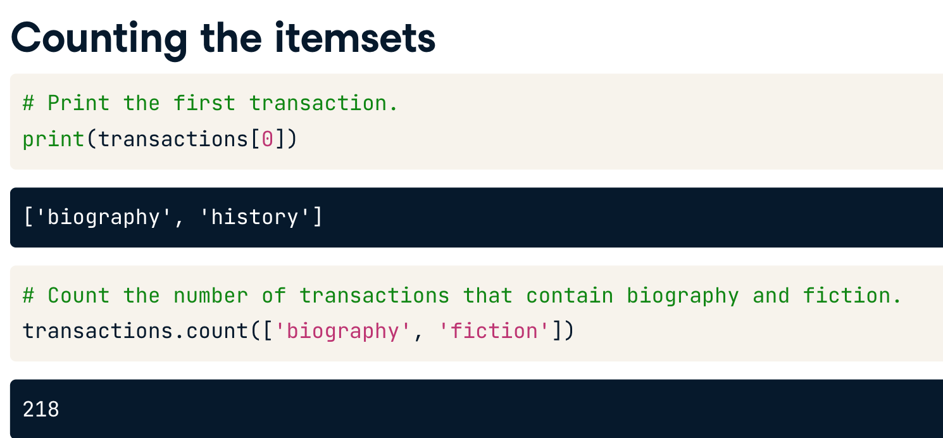

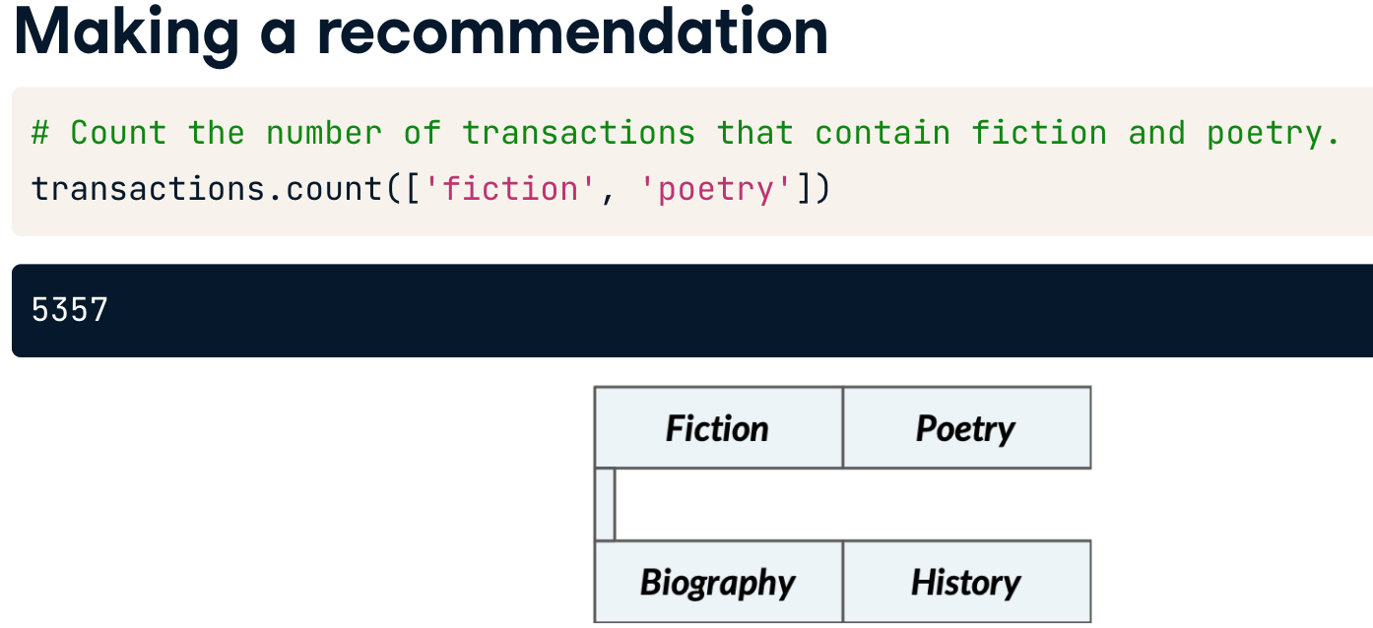

1.1

Market basket analysis uses lists of transactions to identify useful associations between items. Such associations can be written in the form of a rule that has an antecedent and a consequent. Let's assume a small grocery store has asked you to look at their transaction data. After some analysis, you find the rule given below.

**{cereal}**→**{milk}**